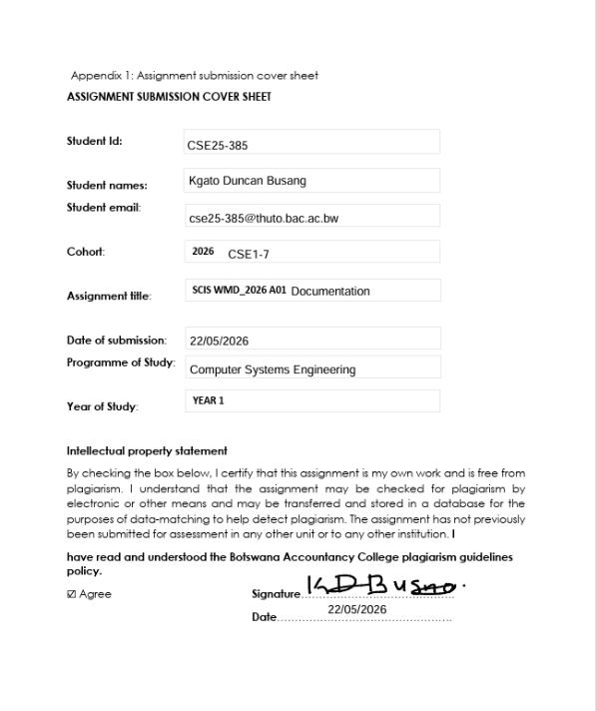
Website Specifications, Information Design &Taxonomy, Technical Brief

POWERUP BATTERIES

Website objective and goals
Objective:
The main objective is to provide engaging, informative and accessible content about electric vehicle batteries, consisting of how they operate, their benefits alongside their environmental impact and manufacturing. Selling services are also offered as customers are able to purchase Electric Vehicle Batteries (EV) from PowerUp Batteries.

Goals:
a) To impart knowledge to users concerning electric vehicle batteries and sustainable energy (Green energy).
b) To promote awareness of environmentally friendly transport solutions.
c) To build credibility by creating quality electric vehicle batteries because it is an upcoming company, and providing up-to-date information.
d) To attract potential customers or investors interested in electric vehicle (EV) battery technology.
e) To encourage user interaction such as inquiries and feedback.

Target audience
- Age group: 20 – 50 years
- Gender: Male and Female
- Location: Urban and semi - urban areas because those are the people with access to electric vehicle (EV) technology.
- Occupation: Majority of them are students, professionals, researchers or working in any other sector and environmental enthusiasts.

Demographics
- People considering to buy electric vehicles.
- Businesses are also venturing into using electric vehicles as transport to contribute to sustainability.

Technical aptitude
- Majority of the target audience may have basic to intermediate computer skills.
- They may be familiar with browsing through websites, literacy usage of smartphones and computers.
-They may be familiar with basic navigation from menus to links and forms.
- Content will be simple, clear and easy to understand because others may not have thorough technical knowledge.

Type of Website
The website is an informational website and includes elements of an educational website, since there are explanations of various types of electric vehicle batteries.
It also has elements of a business website since there are battery products that are showcased.

Content to be designed
- Diagrams and images showing how batteries function.
- Articles and explanations about electric vehicle batteries.
- Information about environmental impact.
-Contact and inquiry forms
- FAQ’s section.
- Benefits of using electric vehicle batteries.

Information Design and Taxonomy

Below is a hierarchical structure that has my site map of how my pages will inter linked to design my website.

index.html
about.html
products.html
- Car battery A
- Car battery B
technology.html
- solar charging
- power charging

- images
- logo.png
- Electronic Vehicle.jpg
- car battery A & B
-cart.html
-payment.html
-README.md
-contact.html

The above hierarchy will be the way my website is structured, the site map will navigate by;
-index.html: This is the homepage where the introduction of the battery company (PowerUp Batteries) is.
-about.html: This is where the company background will be stated in the website.
-products.html: This is where my electric car battery products will be found such as the model of the battery.
-technology.html: In This page I’ll be giving a brief explanation of how various batteries function when installed in the electric vehicle.
-cart.html: This is where end users can temporarily store their preferred battery products before purchasing.
-payment.html: This section customers/end users will be expected to fill in their credit card credentials when ready to purchase, they will also be various payment options.
-contact.html: This is where customers can find PowerUp batteries telephone numbers and e-mail, they can also send an e-mail to the company if they have any enquiries.
-styles.css: It handles the design of the website such as the colors, layout and font-styling.
-images: This is where all electric vehicles and battery images/visuals will be found.
-script.js: It makes the page interactive by making the buttons clickable, and gives form validation. This is where the JavaScript of my website will be.
-README.md: This is where all the project name and description are found.

Below is the Site Map:
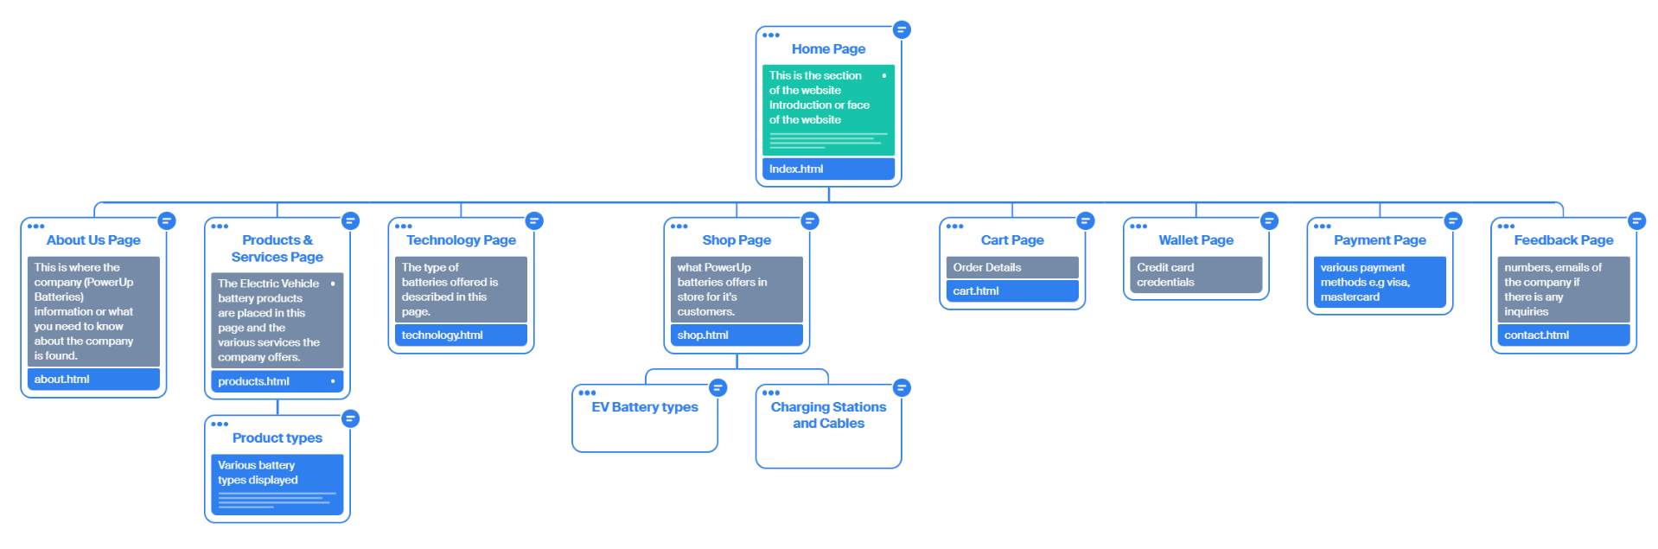

Technical Brief

During the development of the website, various software and graphic tools will be used to create the website. The tools will enable to design, edit codes and test the website through various websites such as Google Chrome, Microsoft Edge and Safari.

VS Code will be used to edit HTML codes and CSS styling.

This is an illustration of how VS code will be used for the editing of HTML files and styling.

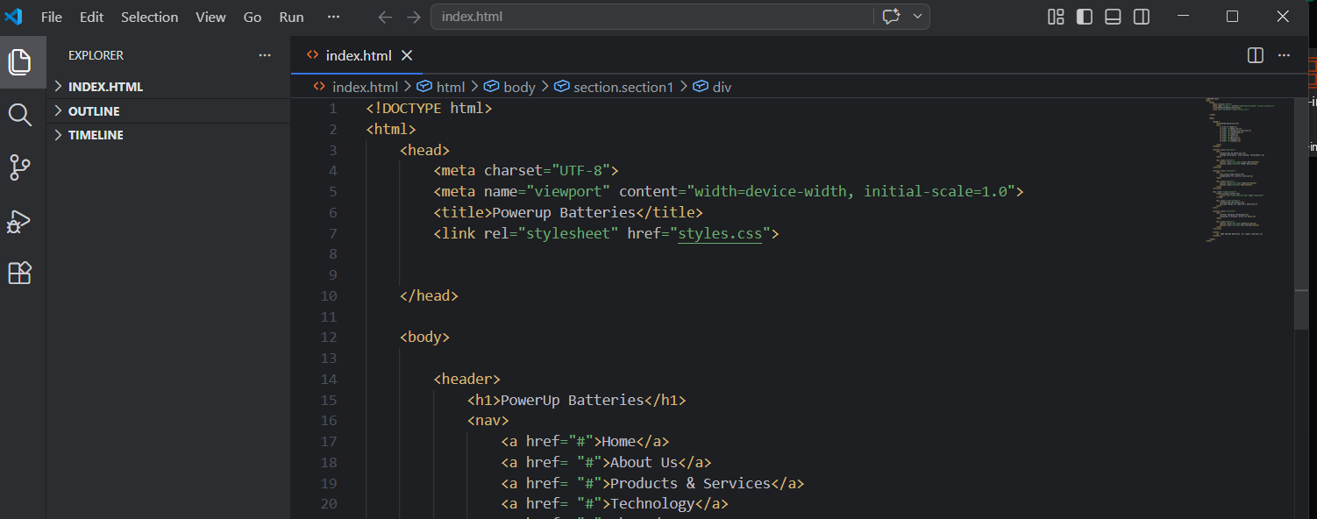

Canva will be used to design website templates before coding the actual website.
Below is an illustration of how Canva was used for the wireframe to add images, background color and text box spacing.

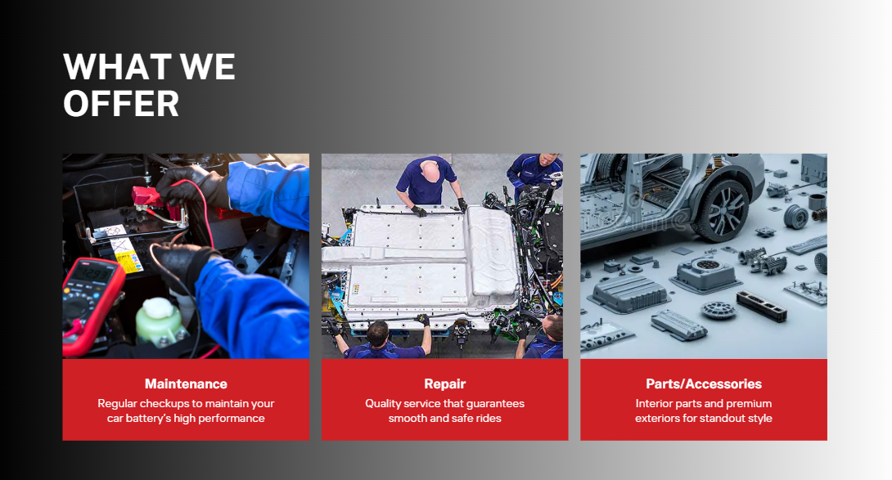

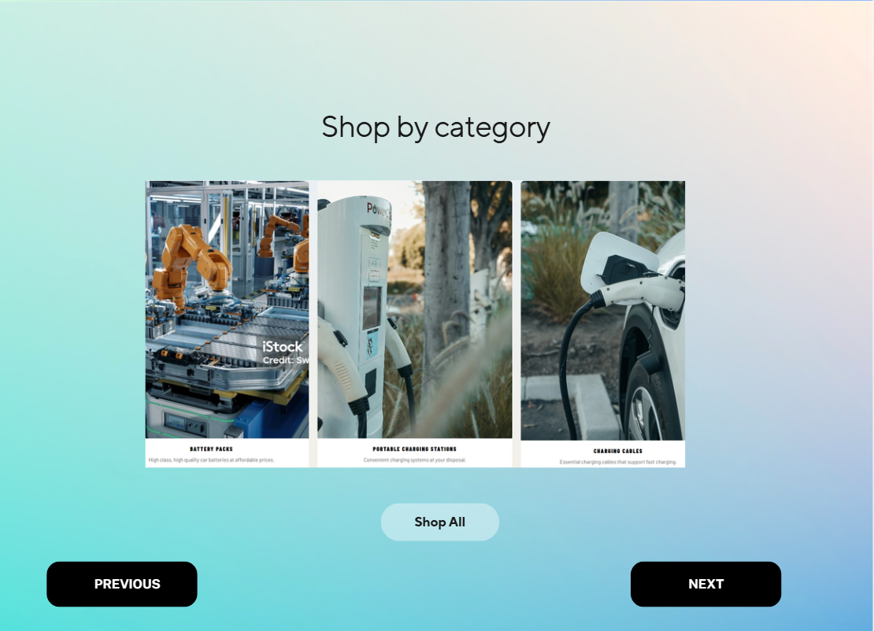

GitHub will be used to publish the website, pages and codes.
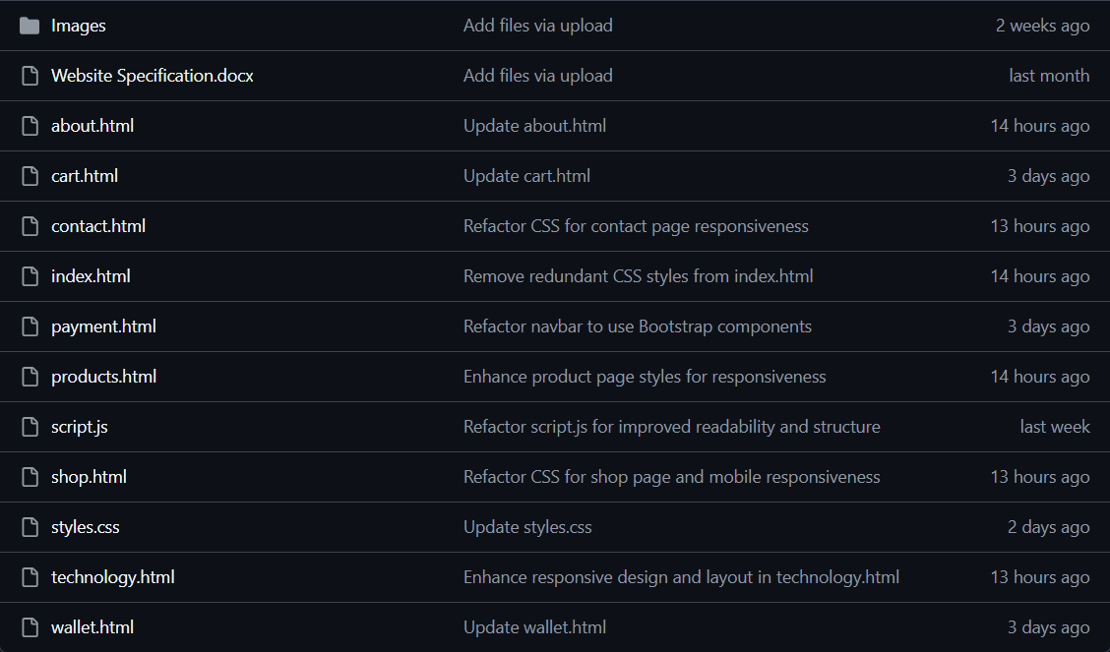

Page Template design wireframes

Low Fidelity Template

Home Page
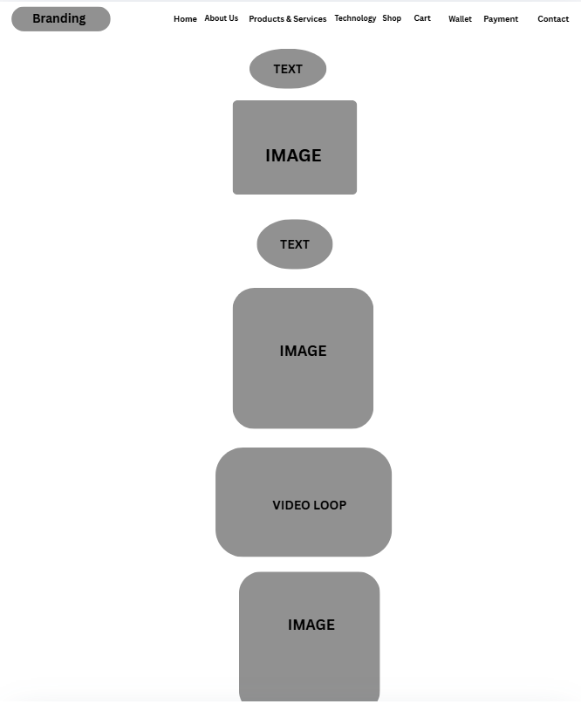
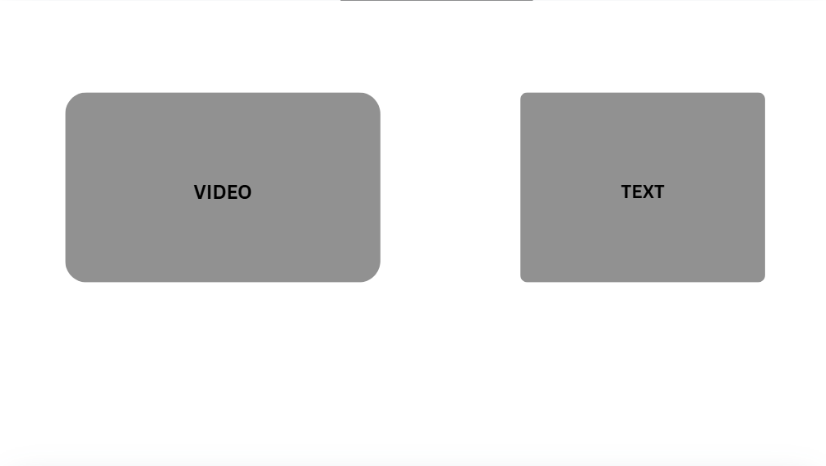

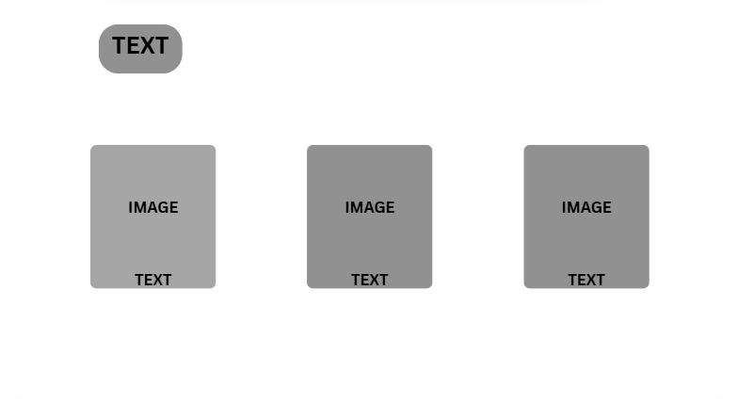

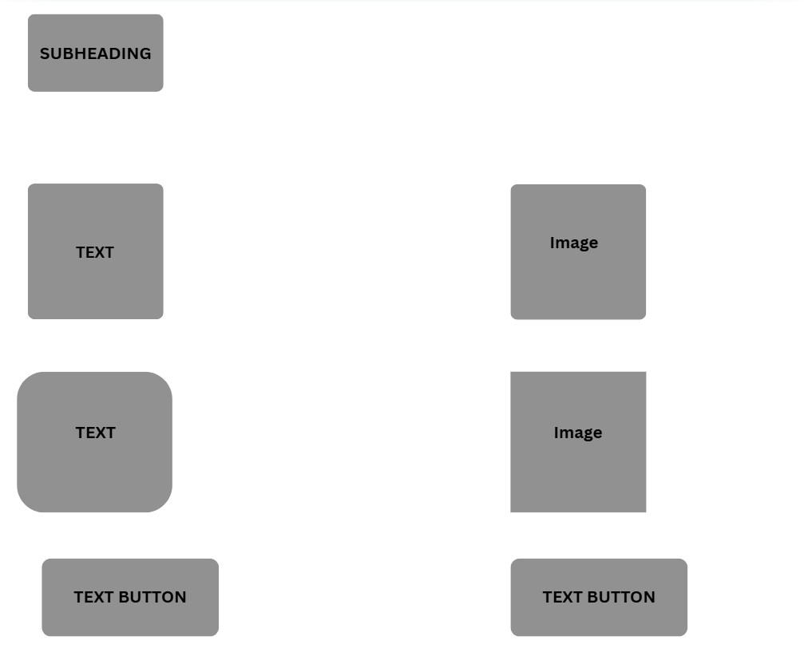

About Page
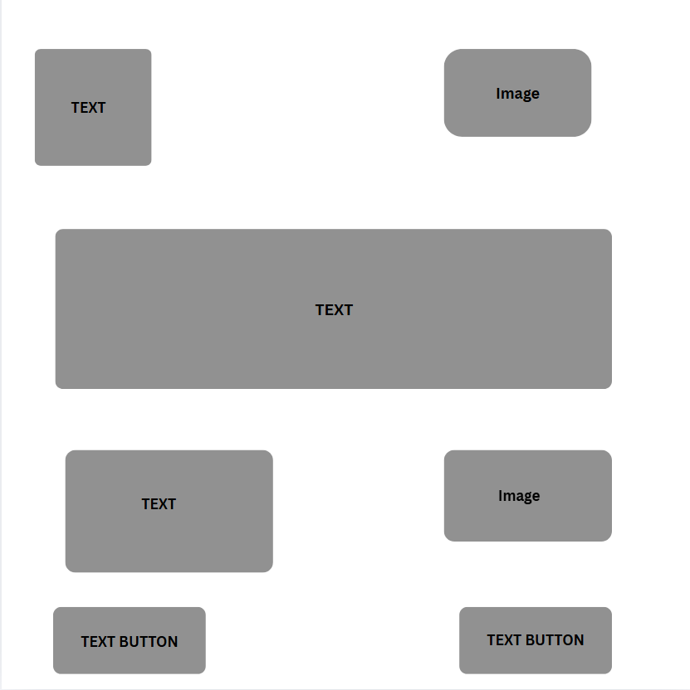

Products & Services Page
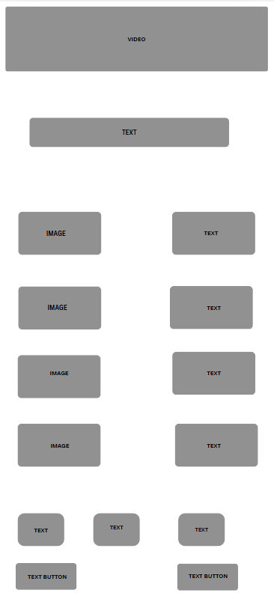

Technology Page
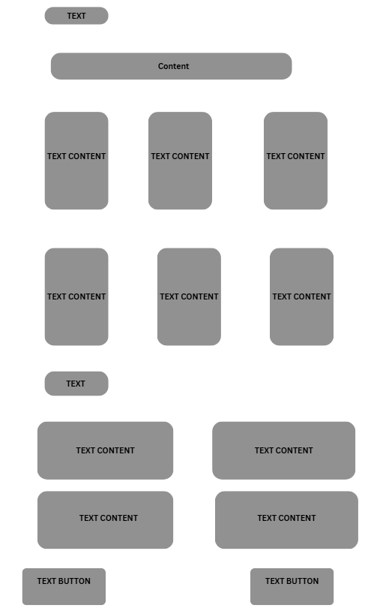

Shop Page
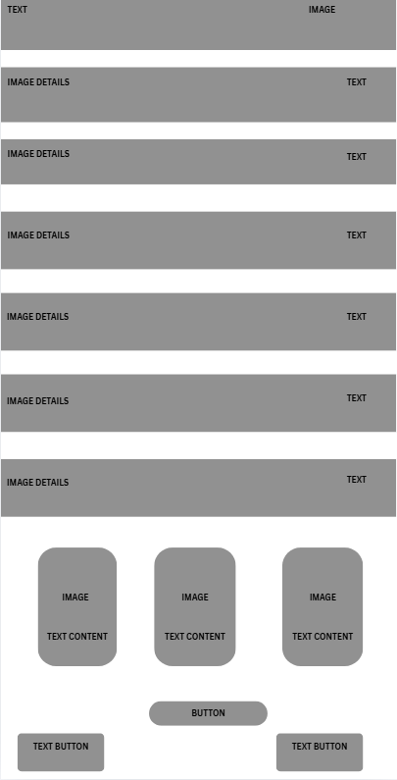

Cart Page

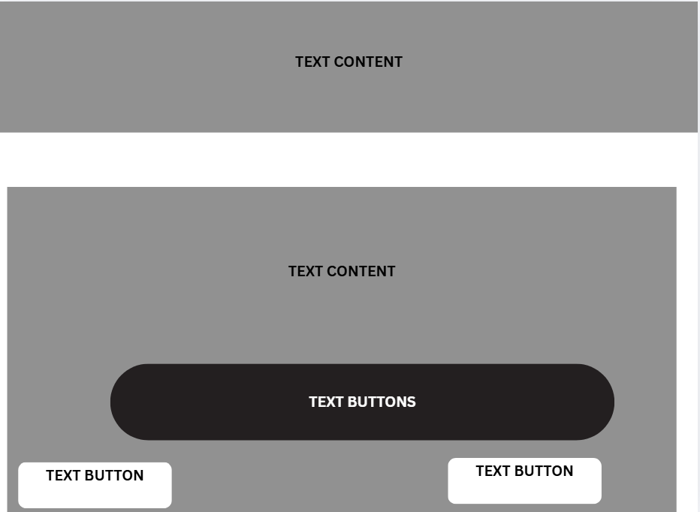

Wallet Page

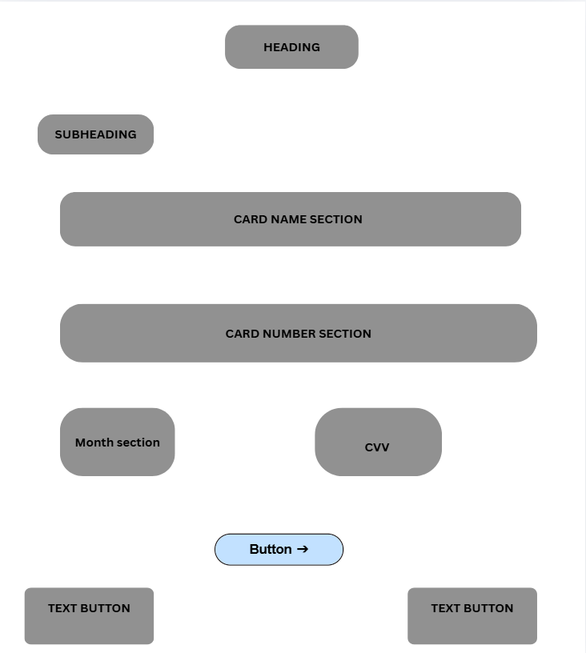

Payment Page
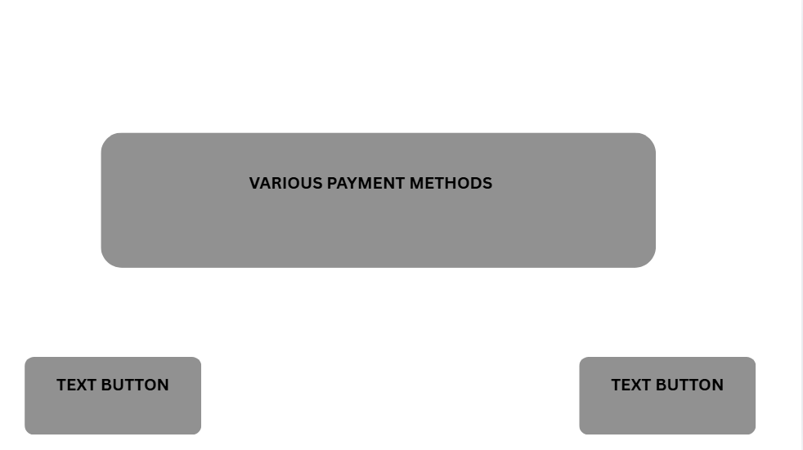

Contact Page
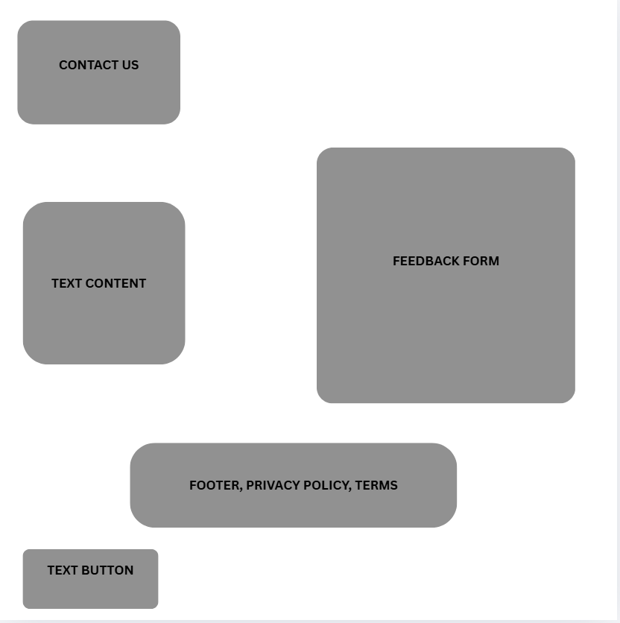

High Fidelity Template

Home Page

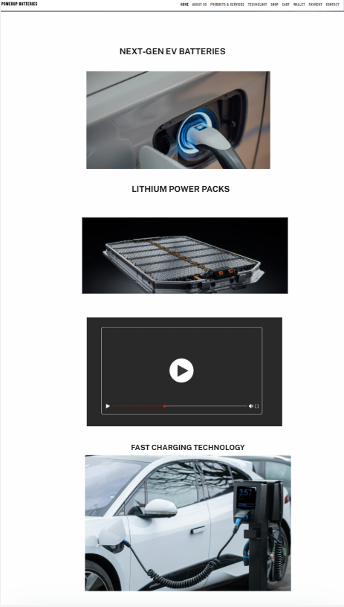
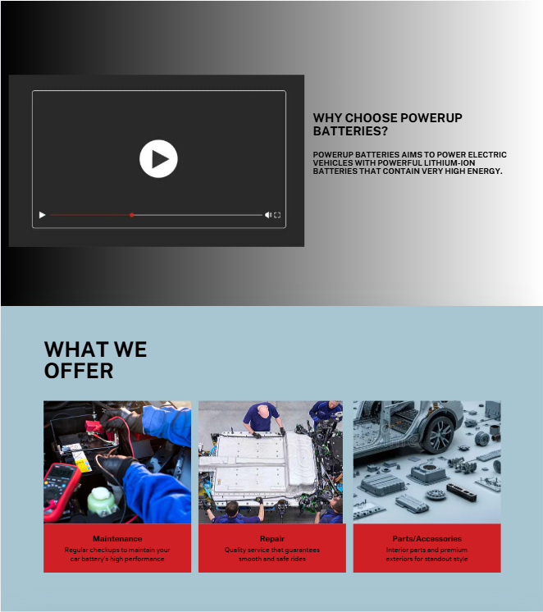
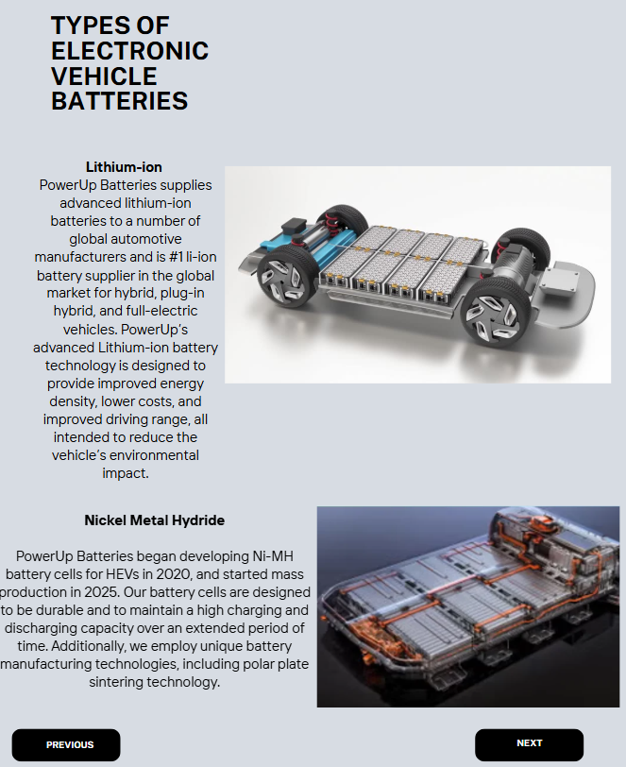

About Page
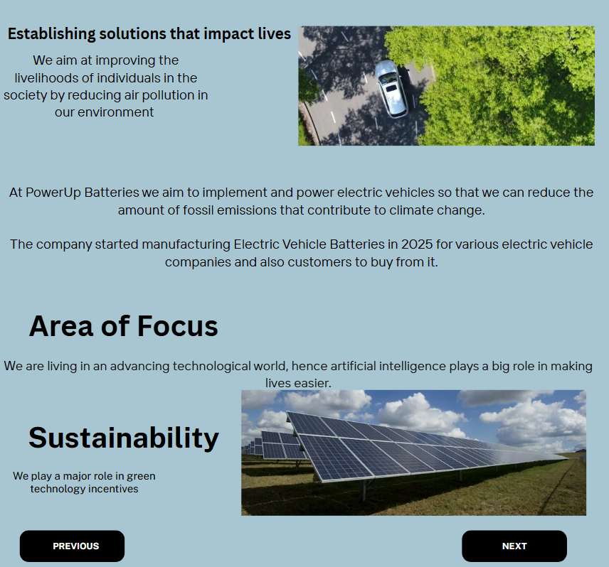

Products & Services Page
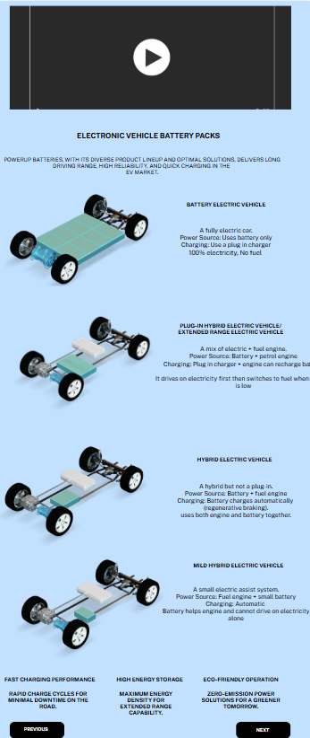

Technology Page
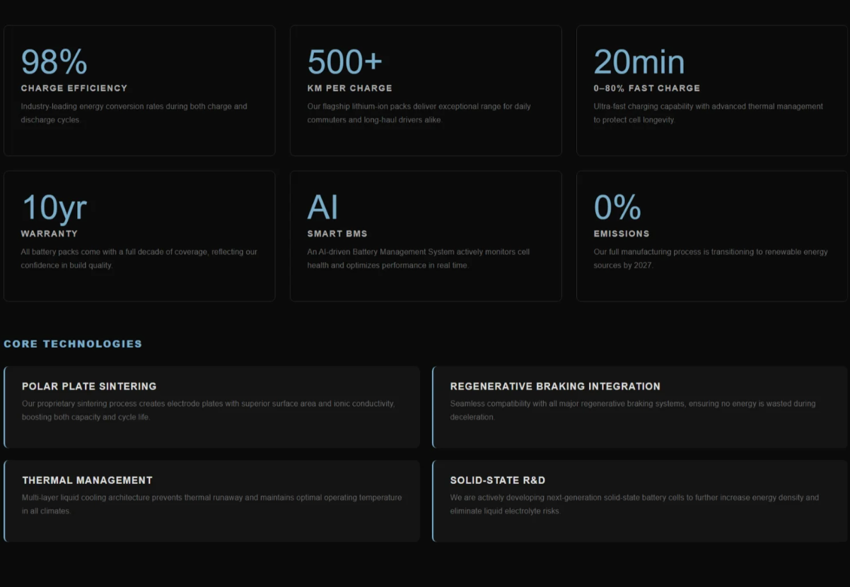

Shop Page
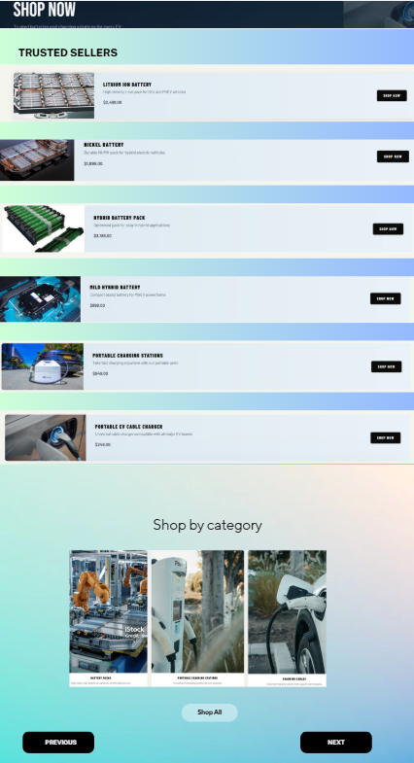

Cart Page
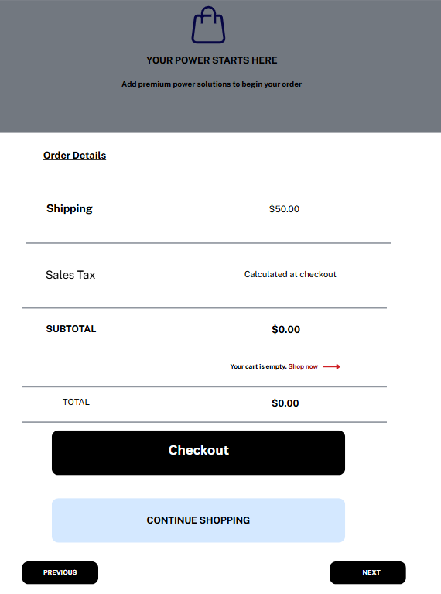

Wallet Page
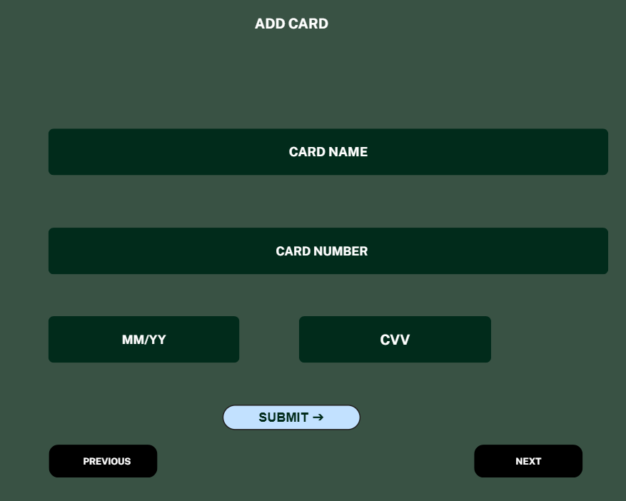

Payment Page
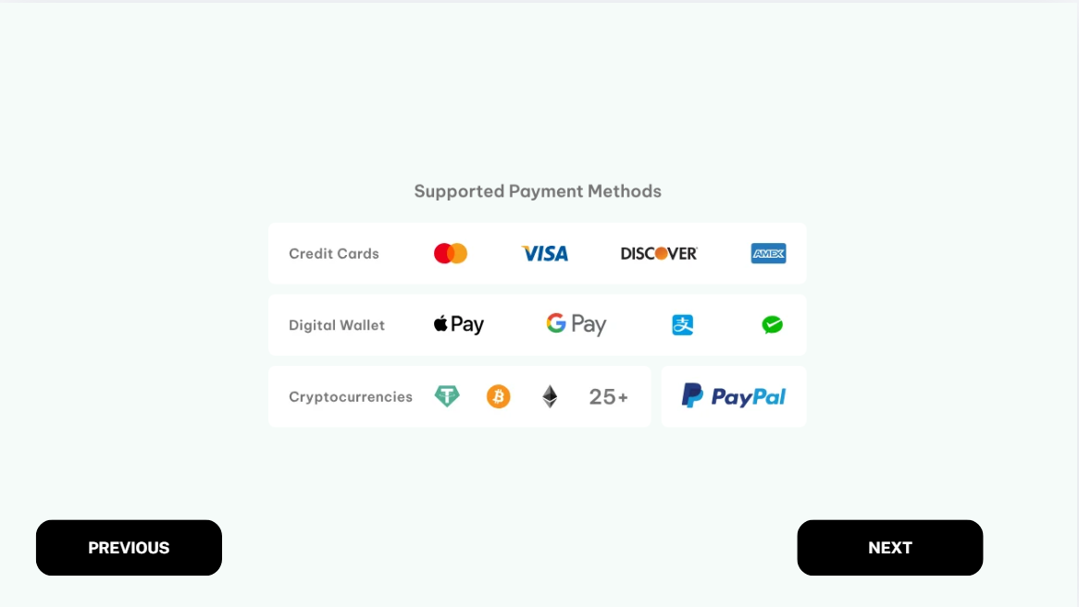

Contact/Feedback Page

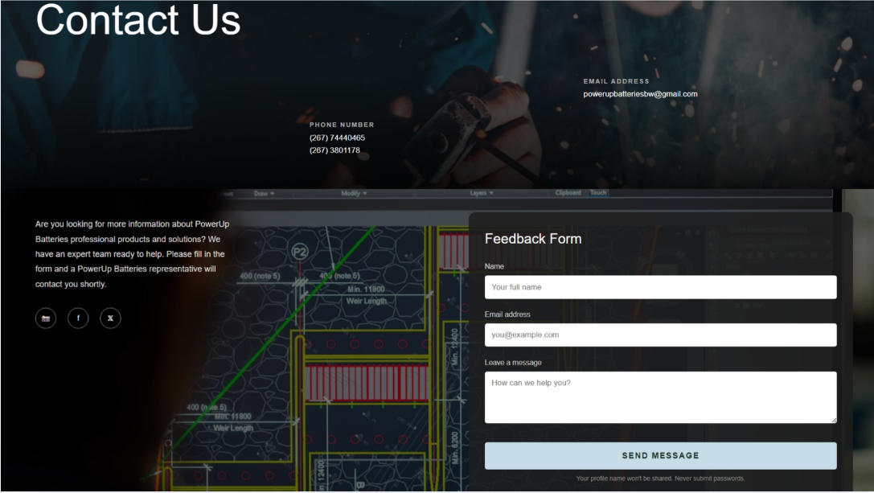

Quality Assurance

I tested the website in various devices and browsers to ensure it is compatible.
Conducted Tests:
Browser Compatibility Testing
The website was tested in the following browsers:
-Microsoft Edge
-Google Chrome
-Safari

Testing the website on multiple browsers was to ensure consistent layout, navigation and functionality was adhered across these platforms.

Mobile Device Testing
The website was tested in the following devices:
-Mobile Phone
-Laptop

Responsive testing was done to ensure the website adapts properly to different screen sizes through styling such as responsive layouts and media queries.

Functional Testing
Whilst testing the browser compatibility and mobile device responsiveness, the following features were also tested:
-Navigation Links
-Images
-Navigation Menu icon (Hamburger)
- Forms
-Buttons
All these features were tested to ensure functionality.

Website Screenshots

Desktop View
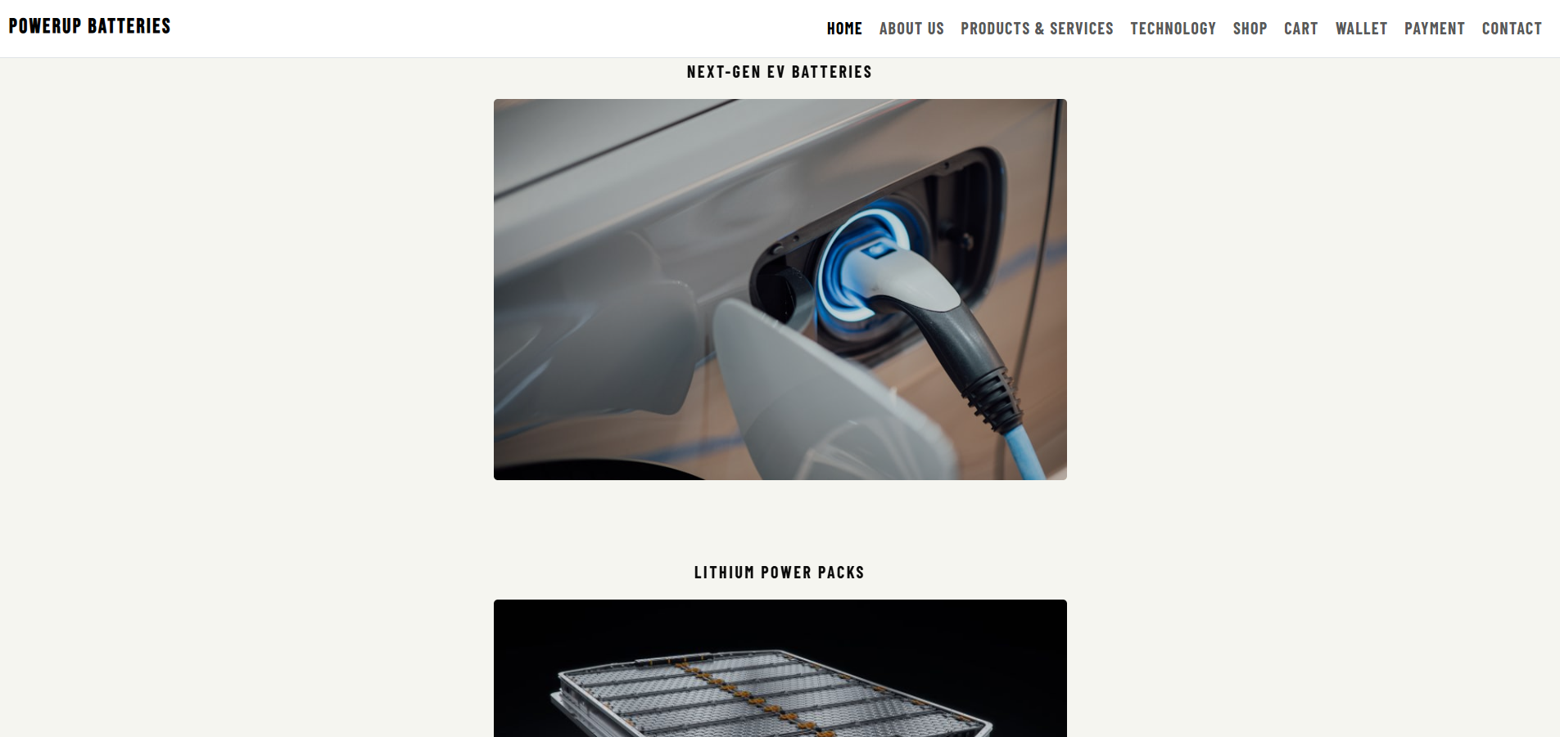

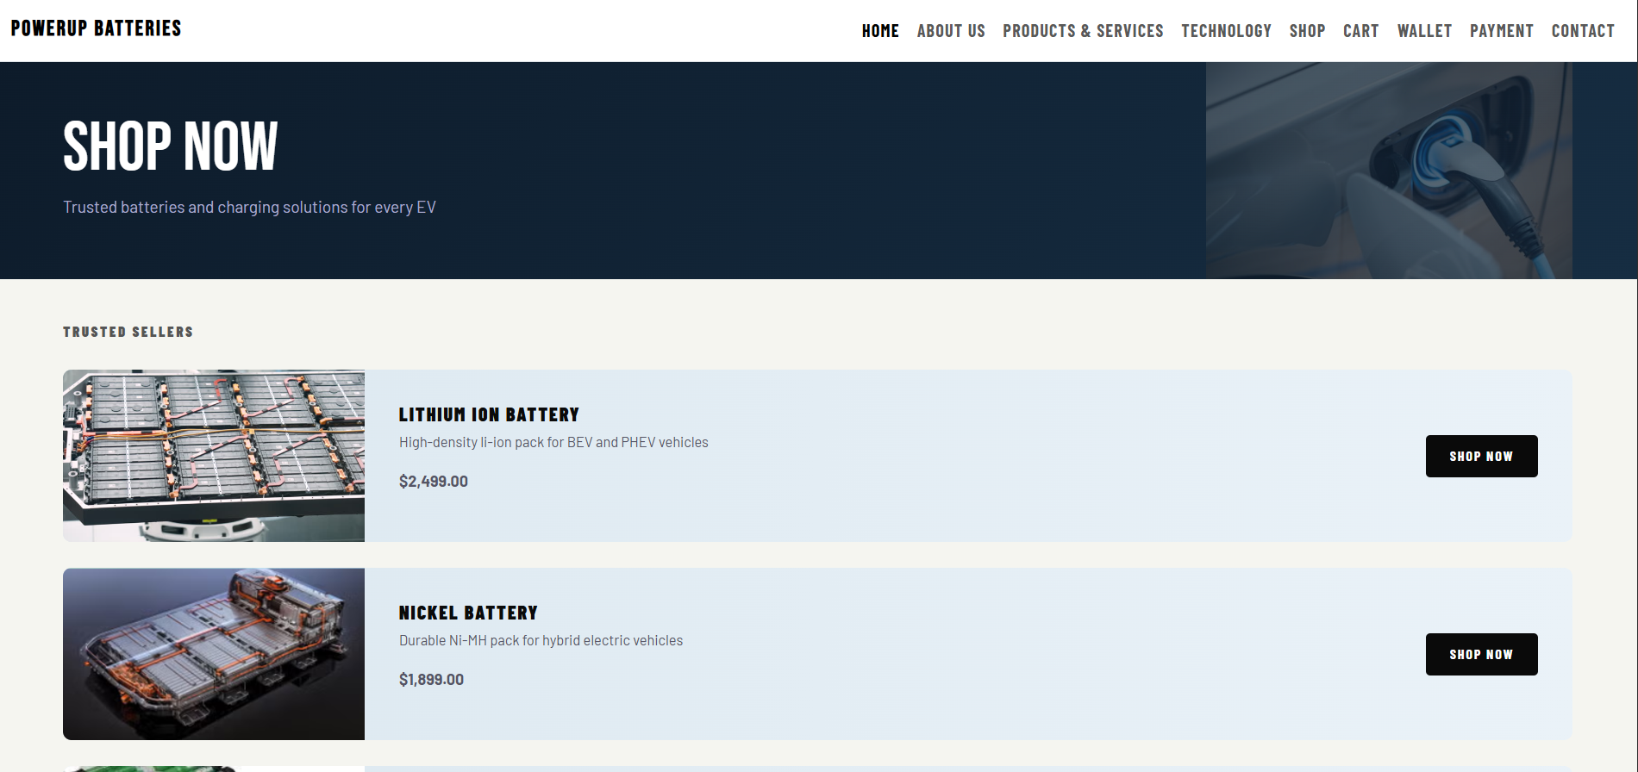

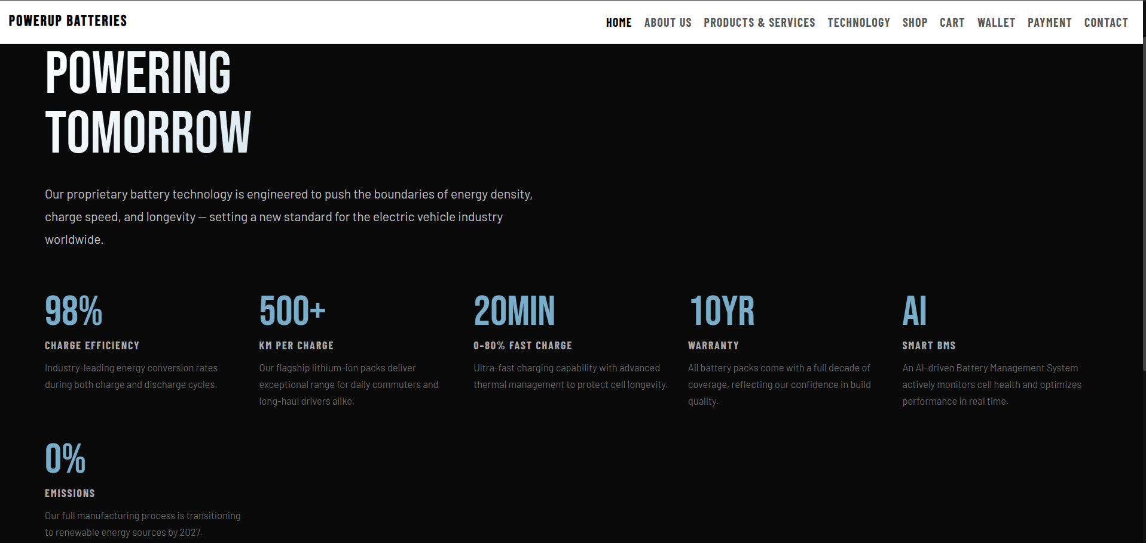

Mobile View
Responsive layout and navigation menu
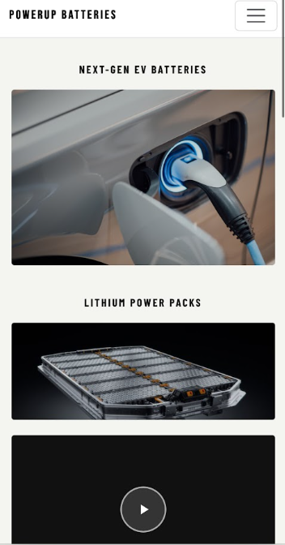
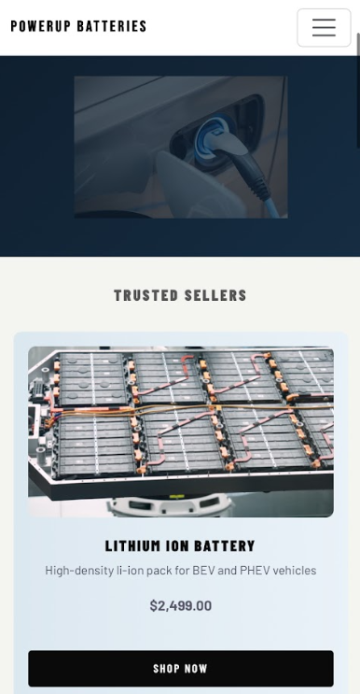
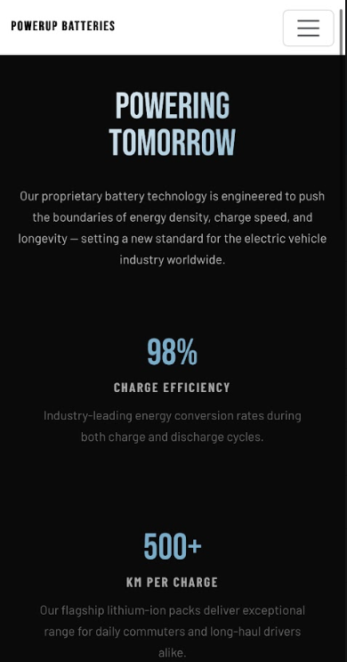
Browser Compatibility Testing

Google Chrome browser Test
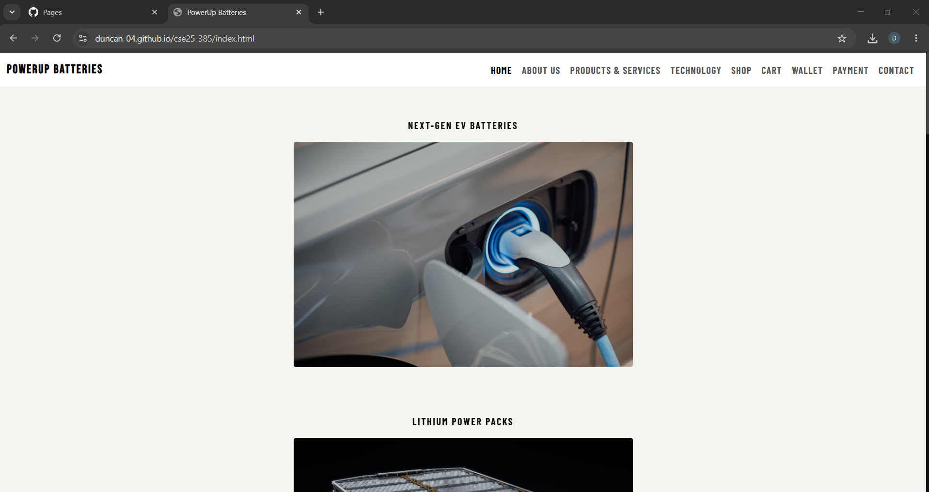
Microsoft Edge browser Test
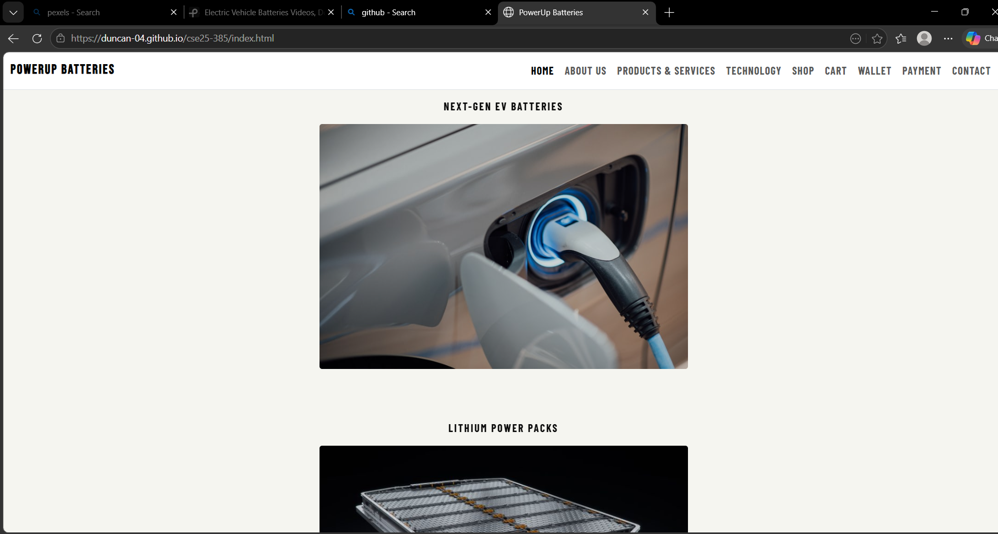

Safari browser Test (Mobile Responsive layout)
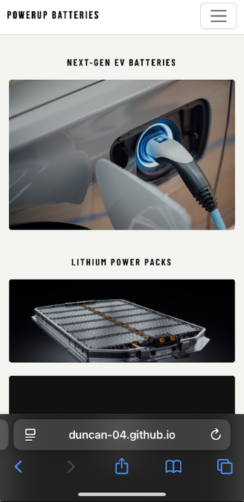

Responsive navigation menu
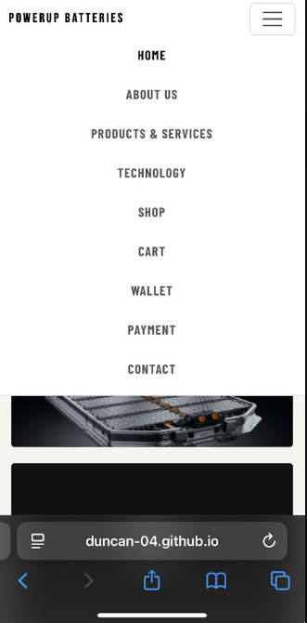
Publishing and Promotion

Website Hosting
GitHub pages was used to host the website.

The tools used to implement the website are:
-VS Code- for HTML coding
-GitHub- for uploading the codes to each project file in the repository

GitHub Commands that were used
The following Git commands were used to upload and publish the website to GitHub pages.
-Git branch main
It was used to rename the default git branch to main.
-Git init
It was used to initialize a local repository for the website.
-Git add
It was used to add HTML, CSS and JavaScript project files to the staging area.

GitHub Pages was enabled from the repository settings to host the website online, after uploading the project files to GitHub.

Deployment Process
Step:
1. Created the GitHub repository
2. Uploaded project files (HTML Pages, JavaScript file and Styles.css file)
3.Enabled GitHub pages
4. Published the website online, by making it public

Repository Link: https://github.com/duncan-04/cse25-385
Website Link: https://duncan-04.github.io/cse25-385/

Future Developments/Recommendations

-Add more responsive layouts for multiple devices.
-Add more shopping products.
-Improve accessibility features.
-Add more hovering effects to images.
-Improved functionality such as more interactive JavaScript.
In the future this website will be improved by elevating responsiveness for multiple devices, additional features such as accessibility will be included and optimization of website loading speed.

